

**Bharati Vidyapeeth (Deemed to be University), Centre for Distance and Online Education, Pune School of Online Education**

**Project Report**

**On**

# “**Food Ordering System**”

**Submitted in Partial Fulfilment of the Requirements for the**

**Award of Degree of Master of Computer Applications (Online Mode) 2023-2024**

## **Submitted by Name of the Student – Yogita Chinnarathd PRN No - 2445101593**

**Guided by**

**Dr. Shambhu Rai**

Declaration

The project report entitled **Food Ordering System** Submitted to Bharati Vidyapeeth(Deemed to be University), Centre for Distance and Online Education, School of Online Education Pune in partial fulfilment of the requirement for the award of the degree of MCA (Online Mode) is an original work carried out under the guidance of **Dr. Shambhu Rai.** The matter embodied in this project is a genuine work done by me to the best of my knowledge and belief and has not been submitted before, neither to this University nor to any other University for the fulfilment of the requirement of any course of study.



Miss. Yogita Chinnarathod

PRN No. 2445101593

## Acknowledgement

Apart from my efforts, the success of my project depends largely on the encouragement and guideline of many others. I take this opportunity to express my gratitude to the people who have been instrumental in the successful completion of this project.i am gratefully indebted to our esteemed guide **Dr. Shambhu Rai** for his sincere guidance and priceless support which would have been impossible for us to complete this project.Finally, I thank Centre for Distance and Online Education, Pune (CDOE) School of Online Education (SOE) for giving me this golden opportunity to do my minor project.



Miss. Yogita Chinnarathod

PRN No. 2445101593

**CHAPTER 1 : INTRODUCTION**

**1.1. Introduction about Project**

A Food Ordering System is a software application designed to simplify the process of ordering food from restaurants, cafe’s, or cloud kitchens. It allows customers to browse menus, select dishes, customize orders, and make payments conveniently through a mobile app or website. The system streamlines the entire ordering workflow by connecting customers, restaurants, and delivery partners on a single platform.This system reduces wait times, minimizes order errors, and enhances customer satisfaction with features like real-time order tracking, secure payment options, and instant notifications. For restaurants, it improves efficiency by automating order management, inventory updates, and sales reporting. Overall, a food ordering system brings speed, accuracy, and convenience to both customers and businesses in the food service industry.

**1.2. Need of Computerization of System**

The computerization of a Food Ordering System is essential to overcome the limitations of traditional manual ordering methods. In manual systems, taking orders on paper, managing customer requests, and handling billing often lead to mistakes, delays, and miscommunication. A computerized system makes the entire process faster, more accurate, and more organized.

Computerization provides an easy-to-use interface through which customers can browse menus, place orders, and make payments without depending on staff. It reduces human errors, improves order accuracy, and ensures faster service. For restaurants, it streamlines order processing, inventory management, billing, and record-keeping. Managers can also track sales, monitor stock levels, and analyze customer behavior with ease.

Overall, computerization increases efficiency, saves time, reduces costs, and enhances customer satisfaction by making the food ordering process smooth, reliable, and transparent.

**1.3. Proposed Software.**

The proposed food ordering system aims to create a computerized platform where customers can easily browse menus, place orders, and make payments online. Restaurants will receive orders instantly and manage them efficiently through an automated dashboard. The system will reduce errors, save time, and improve overall service quality by replacing manual processes with a fast and user-friendly digital solution.

**1.4. Importance of the Work**

The food ordering system is important because it makes the entire ordering process faster, easier, and more accurate. It reduces manual errors, saves time for customers and staff, and provides a convenient way to browse menus and place orders anytime. For restaurants, it improves order management, increases efficiency, and helps maintain proper records. Overall, it enhances customer satisfaction and supports smooth business operations

## CHAPTER 2 : SYSTEM

## **ANALYSIS**

**2.1. Feasibility Study of s/w includes its types**

**VSCode :**

Visual Studio Code (VS Code) is a free, open-source code editor developed by Microsoft. Due to its lightweight, quick, and highly configurable design, developers for a wide range of programming languages and frameworks find it to be rather popular. Here are some essential details regarding VS Code:

1. Cross-Platform: VS Code ensures a uniform development experience across several operating systems and is available for Windows, macOS, and Linux.
2. Features: It provides a wide range of features, such as support for extensions, syntax highlighting, code completion, code refactoring, linting, debugging, and version control integration (Git). These functions improve output and simplify the development process.
3. Extensions: The community has created a wide range of extensions for Visual Studio Code that increase the program's capability for particular languages, frameworks, and tools. Popular programming languages including JavaScript, Python, and Java as well as frameworks like Angular, React, and Vue.js have extensions available.
4. Customization: With VS Code's wide range of customization options, developers may tailor their editor to their own tastes. To fit the editor to your workflow, you can install extensions, change the keyboard shortcuts, themes, and settings.

**Eclipse :**

A **feasibility study** is conducted to evaluate whether the proposed eCommerce shopping website can be successfully developed and deployed using the Eclipse IDE. It involves analyzing technical, economic, operational, and schedule-related factors.

**1. Technical Feasibility**

-The project utilizes established technologies like Spring Boot, MySQL, and modern web standards

-Development team possesses the necessary expertise in Java and related frameworks

-Required infrastructure for hosting and deployment is readily available

**2. Economic Feasibility**

* Initial development costs are justified by long-term operational savings
* ROI is expected within the first year of implementation
* Reduced need for physical retail space offsets digital infrastructure costs

**3. Operational Feasibility**

-Streamlined user interfaces ensure ease of adoption for both customers and administrators

-Training requirements for staff are minimal due to intuitive design

-The system integrates smoothly with existing business processes

**2.2. Analysis M ethodology**

The ShopEasy project employs multiple analysis methodologies:

**Objectives of Analysis Modelling:**

* Used to model the system using object-oriented concepts (classes, inheritance, etc.)

- Identities key entities such as Products, Users, Orders, and their relationship

**Structured Analysis:**

Employed for process modeling using Data Flow Diagrams - Helps visualize data movement between system components

**Agile Methodology:**

Iterative development approach with regular stakeholder feedback - User stories drive feature development prioritization,

**2.3. Choice of Platforms s/w & h/w**

**2.3.1. Software used**

Front-end : HTML, CSS, Javascript

Back-end : Java

Database : MySql

**2.3.2. Hardware used**

Processor : Modern multi-core processor

Memory (RAM) : At least 4 GB

Storage : Solid-state drive (SSD) preferred

## **CHAPTER 3 : SYSTEM DESIGN**

**3.1. Design methodology**

While design methodology is employed in many industries, it is commonly applied in technology fields, including web application development and information systems. Several design methodology approaches are used in this project:

* **MVC (Model-View-Controller) :**

The application follows the MVC pattern where models (Beans) represent data, views (JSP pages) handle presentation, and controllers (Servlets) manage the flow of the application.

* **Object-Oriented Design :**

The application is designed using object-oriented principles, with classes representing real-world entities (Users, Products, Orders, etc.) and their relationships.

* **Component-Based Design :**

The application is built using reusable components that can be developed, tested, and maintained independently.

**3.2. Database Design**

1. **tblresturant**

|  |  |
| --- | --- |
| **Column Header** | **Data Type** |
| Rid | Varchar(45) |
| Rname | Varchar (100) |
| Rcuisine_type | Varchar (20) |
| Remail | Varchar (350) |
| Pprice | Varchar (12,2) |
| Rphone | Int |
| Raddress | Long |

1. **tbluser**

|  |  |
| --- | --- |
| **Column Header** | **Data Type** |
| Email | Varchar(60) |
| Name | Varchar(30) |
| MobileNumber | Char(10) |
| Address | Varchar(70) |
| Pincode | Int |
| Password | Varchar(20) |

1. **tblorders**

|  |  |
| --- | --- |
| **Column Header** | **Data Type** |
| Orderid | Varchar(45) |
| Prodid | Varchar(40) |
| Quantity | Varchar(50) |
| Amount | Decimal(10,2) |
| Shipped | Int(11) |

1. **tblproduct**

|  |  |
| --- | --- |
| **Column Header** | **Data Type** |
| Pid | Varchar(45) |
| Pname | Varchar (100) |
| Ptype | Varchar (20) |
| Pinfo | Varchar (350) |
| Pprice | Varchar (12,2) |
| Pquantity | Int |
| Pquantity | Longblob |

**5.tblorderitem**

|  |  |
| --- | --- |
| **Column Header** | **Data Type** |
| id | **Int(6)** |
| Menu_item | Varchar(60) |
| Order_id | Varchar(40) |
| Quantity | Int(45) |
| Subtotal | Decimal(10,2) |
| Created_at | Datetime |
| Updated_at | Datetime |

**6.tblmenuitem**

|  |  |
| --- | --- |
| **Column Header** | **Data Type** |
| Mid | Varchar(40) |
| Mrestaurant_id | Varchar(30) |
| Mcategory_id | Int(10) |
| Mname | Int(15) |
| Mdescription | Varchar200) |
| Mprice | Text(100) |
| Mimage | Varchar(100) |
| Mis_available | Boolean(5) |
|  |  |
|  |  |

* 1. **Screen Design**

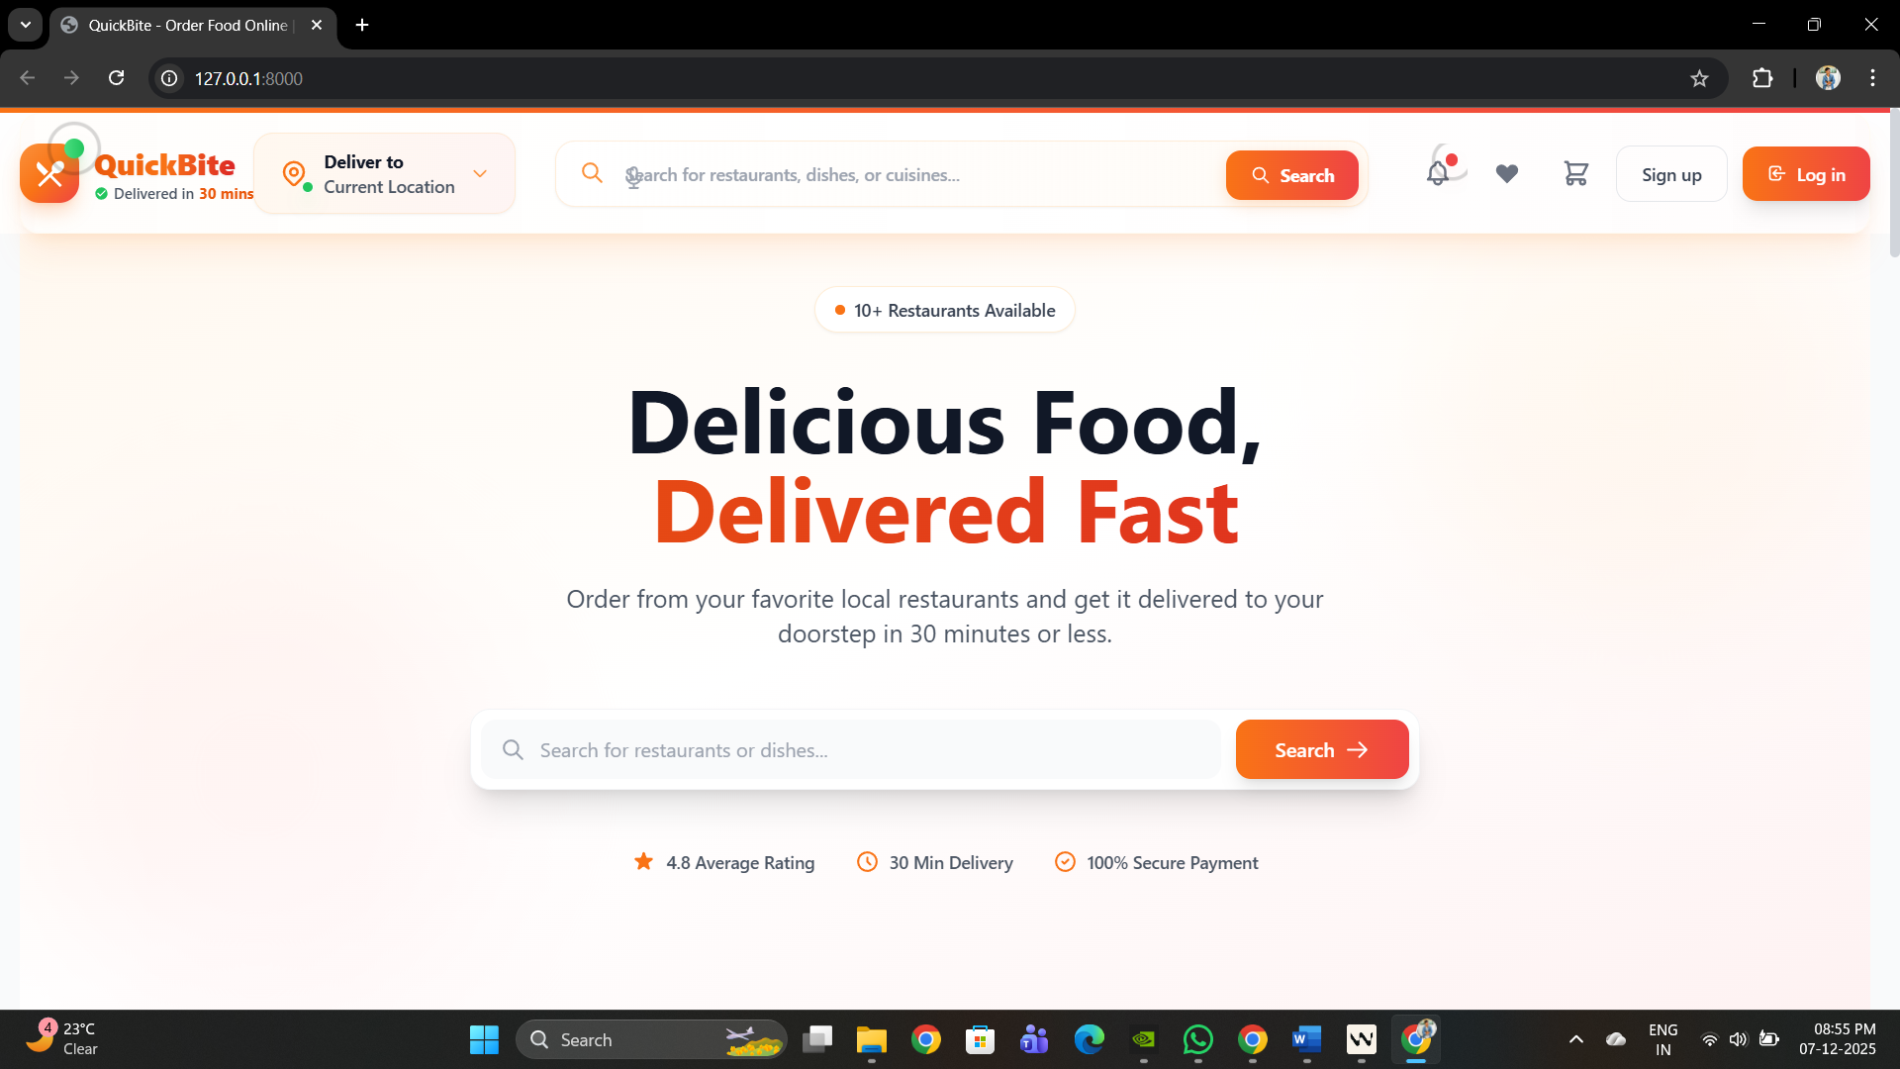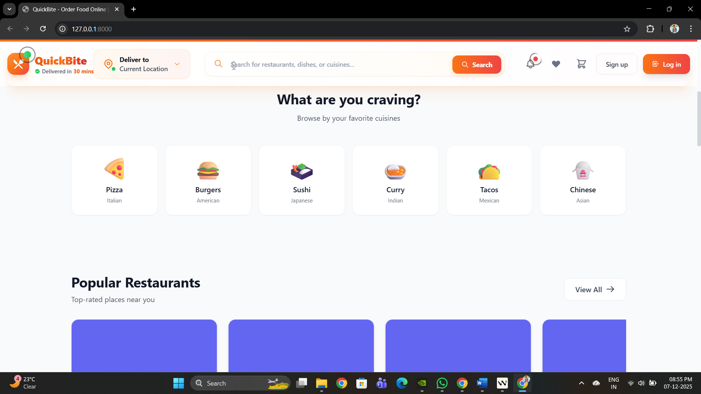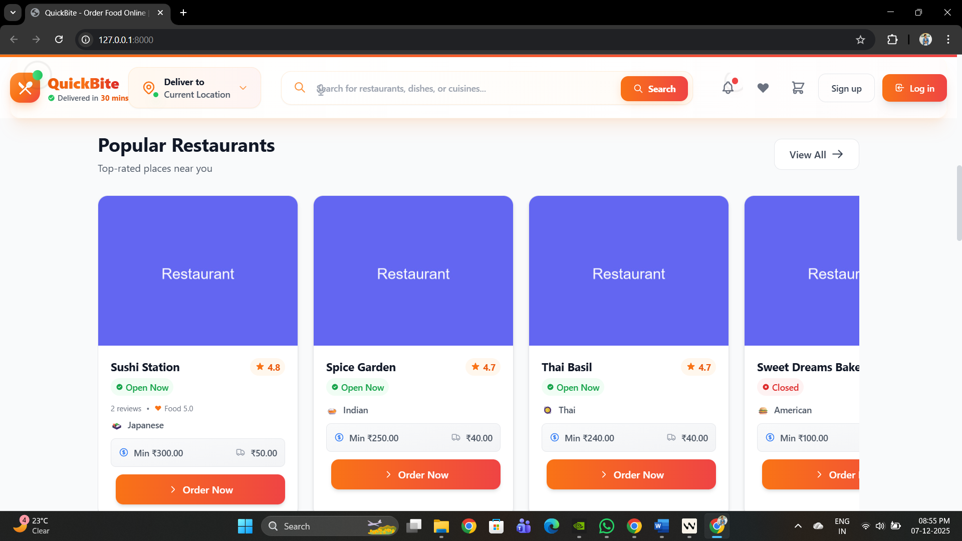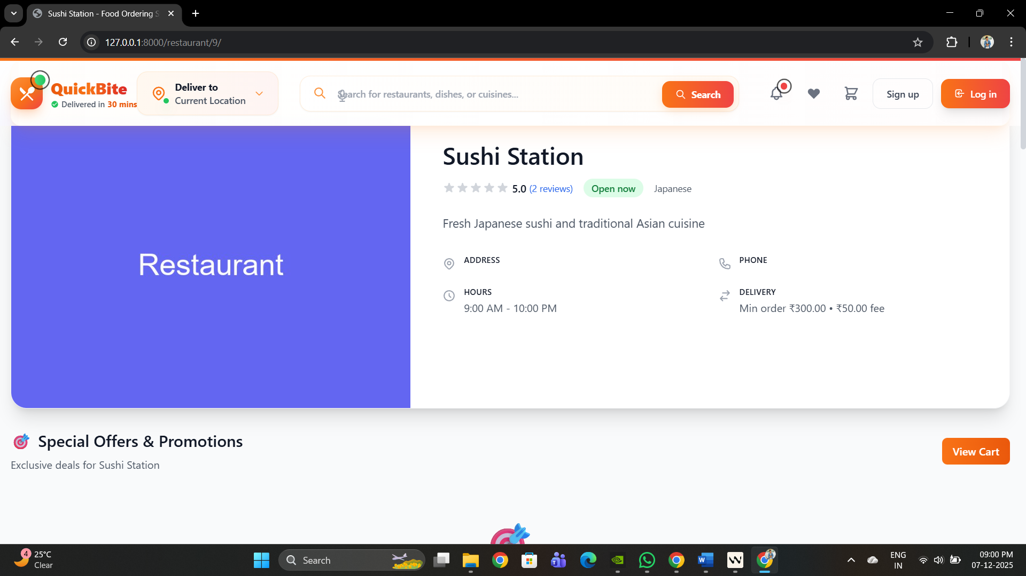

Before login

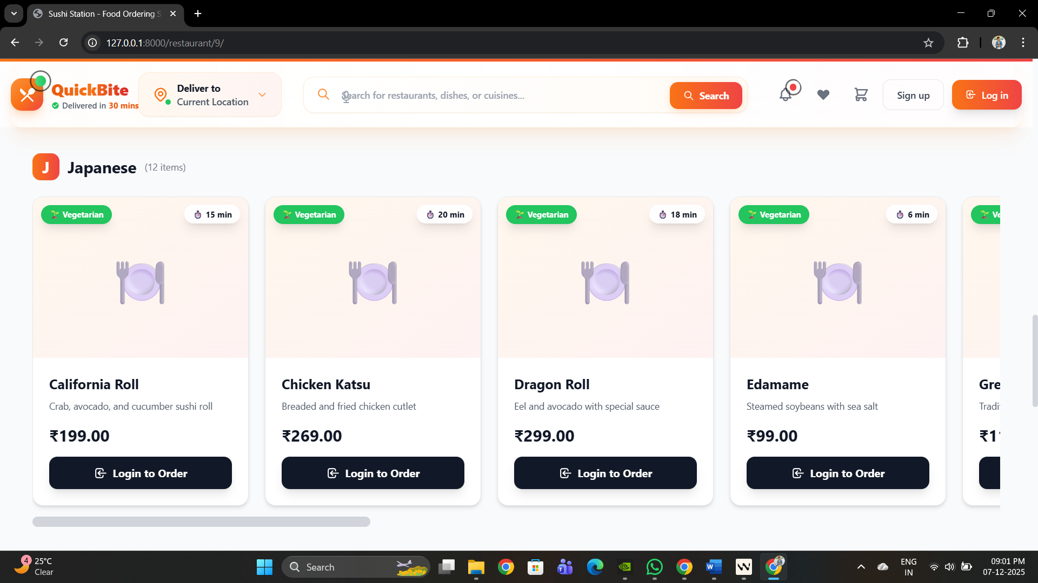

After Login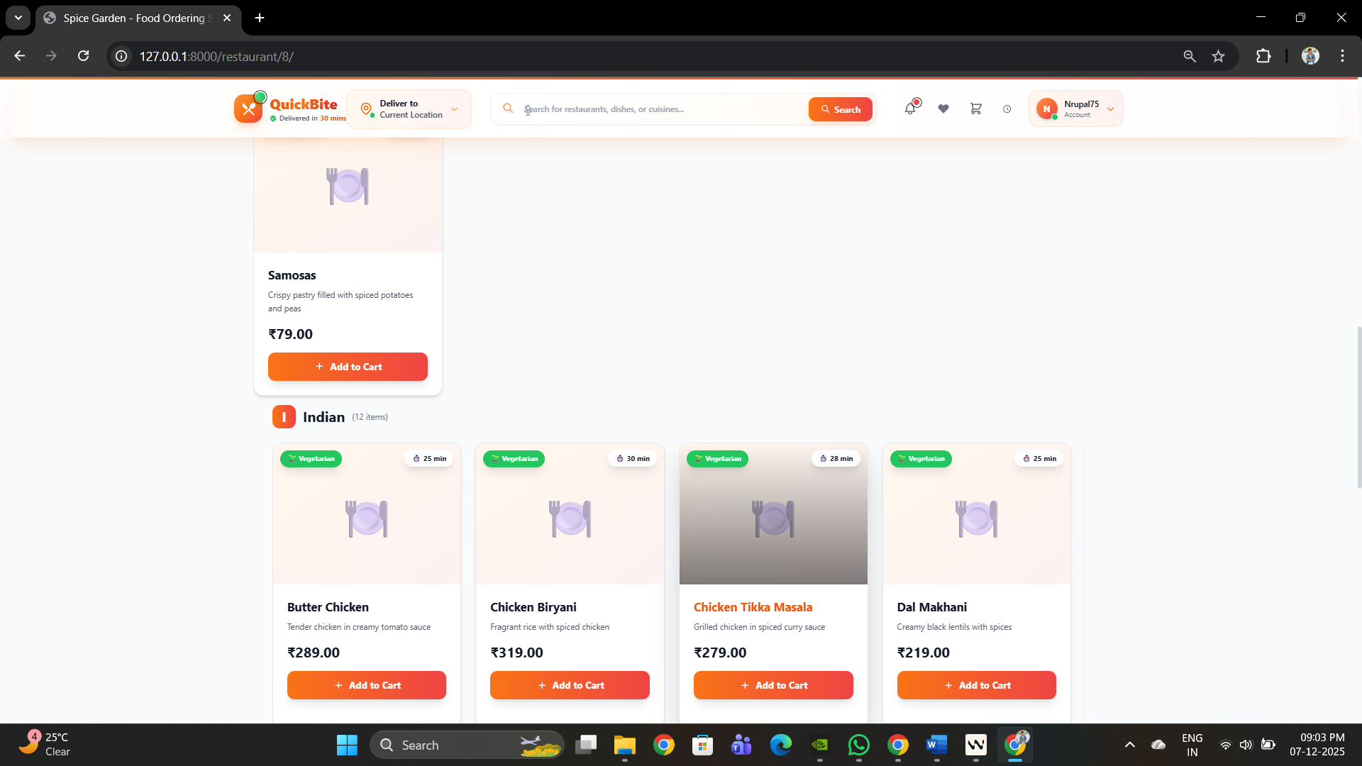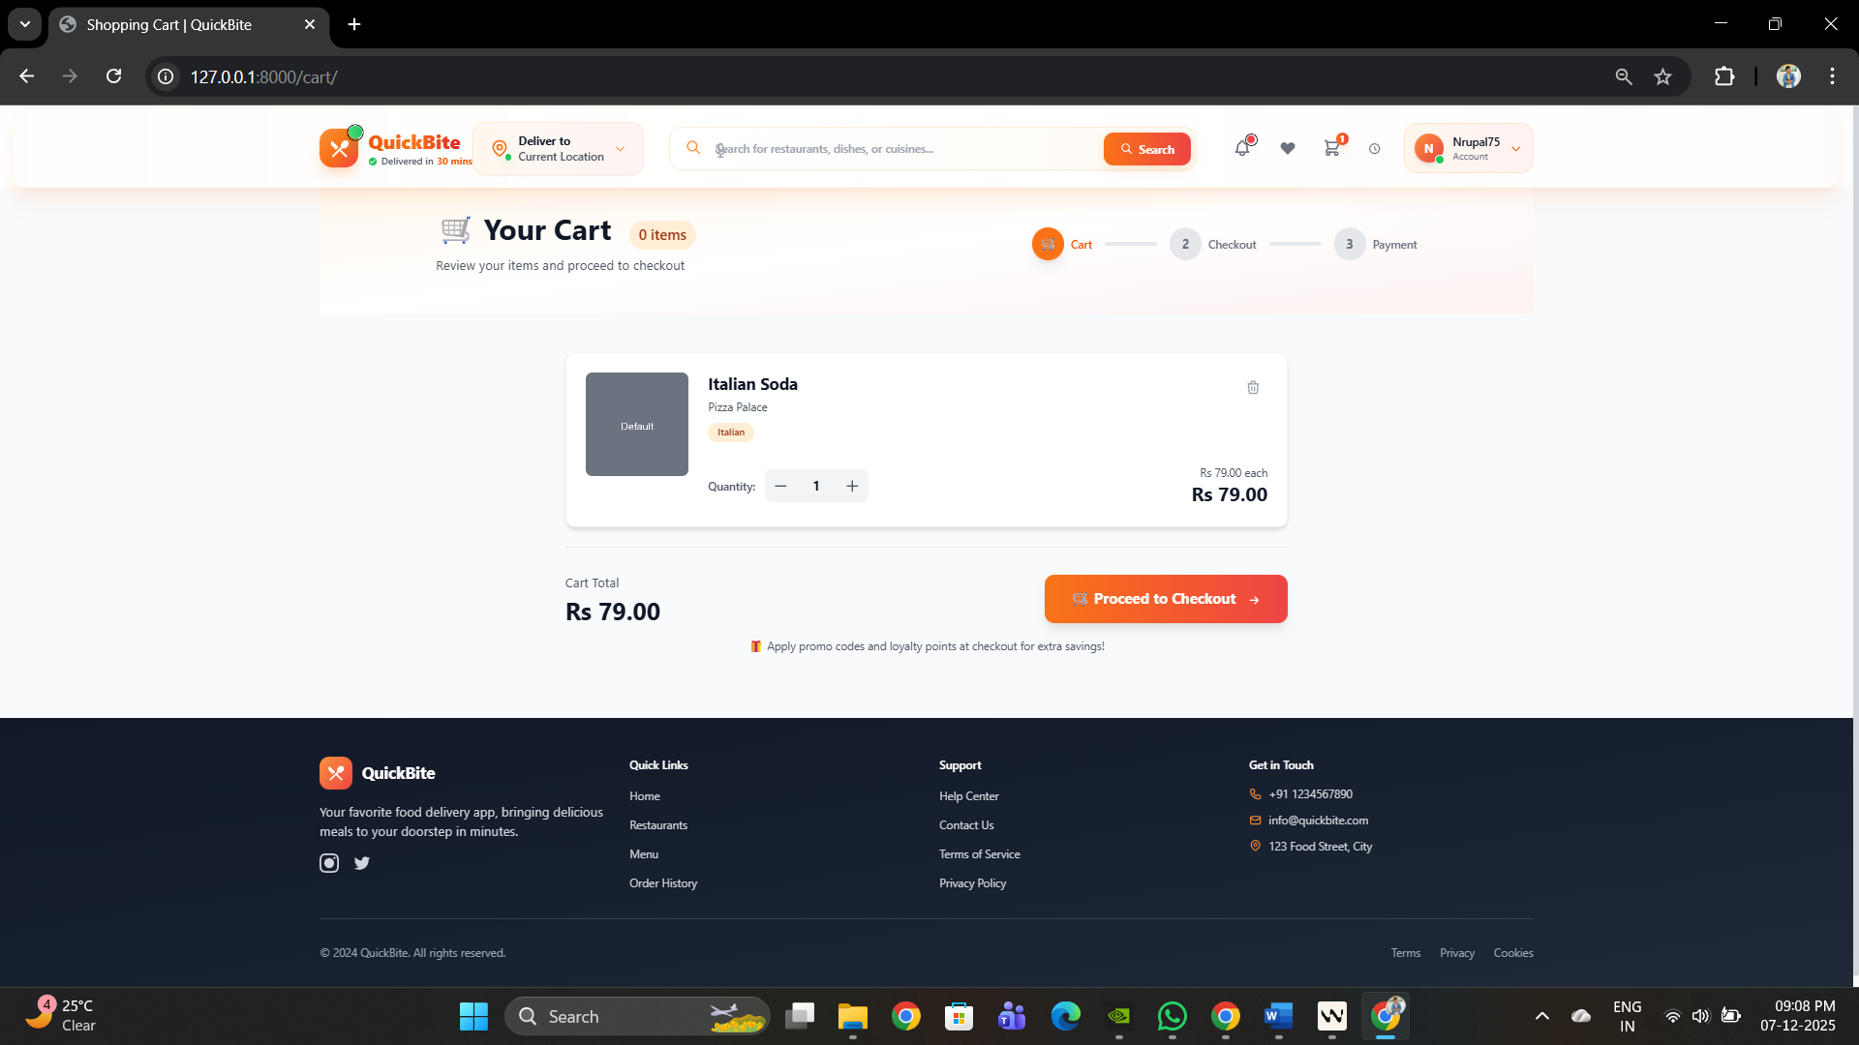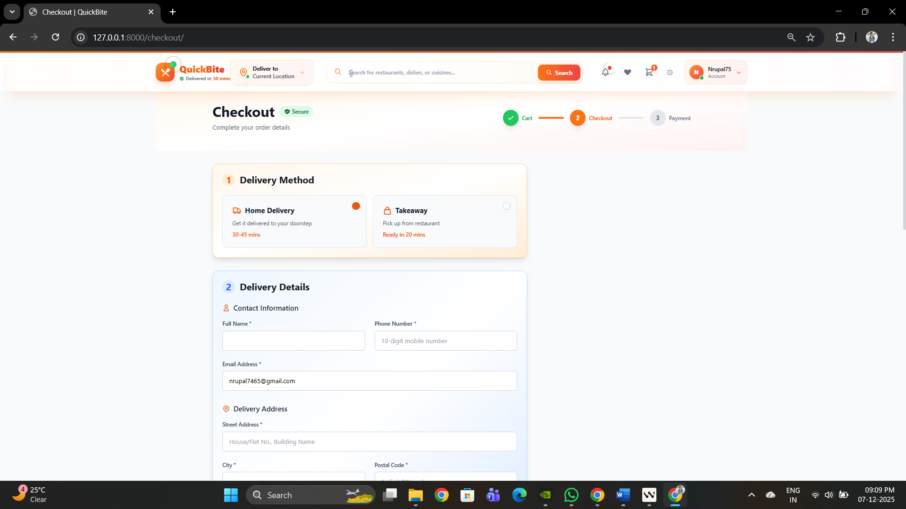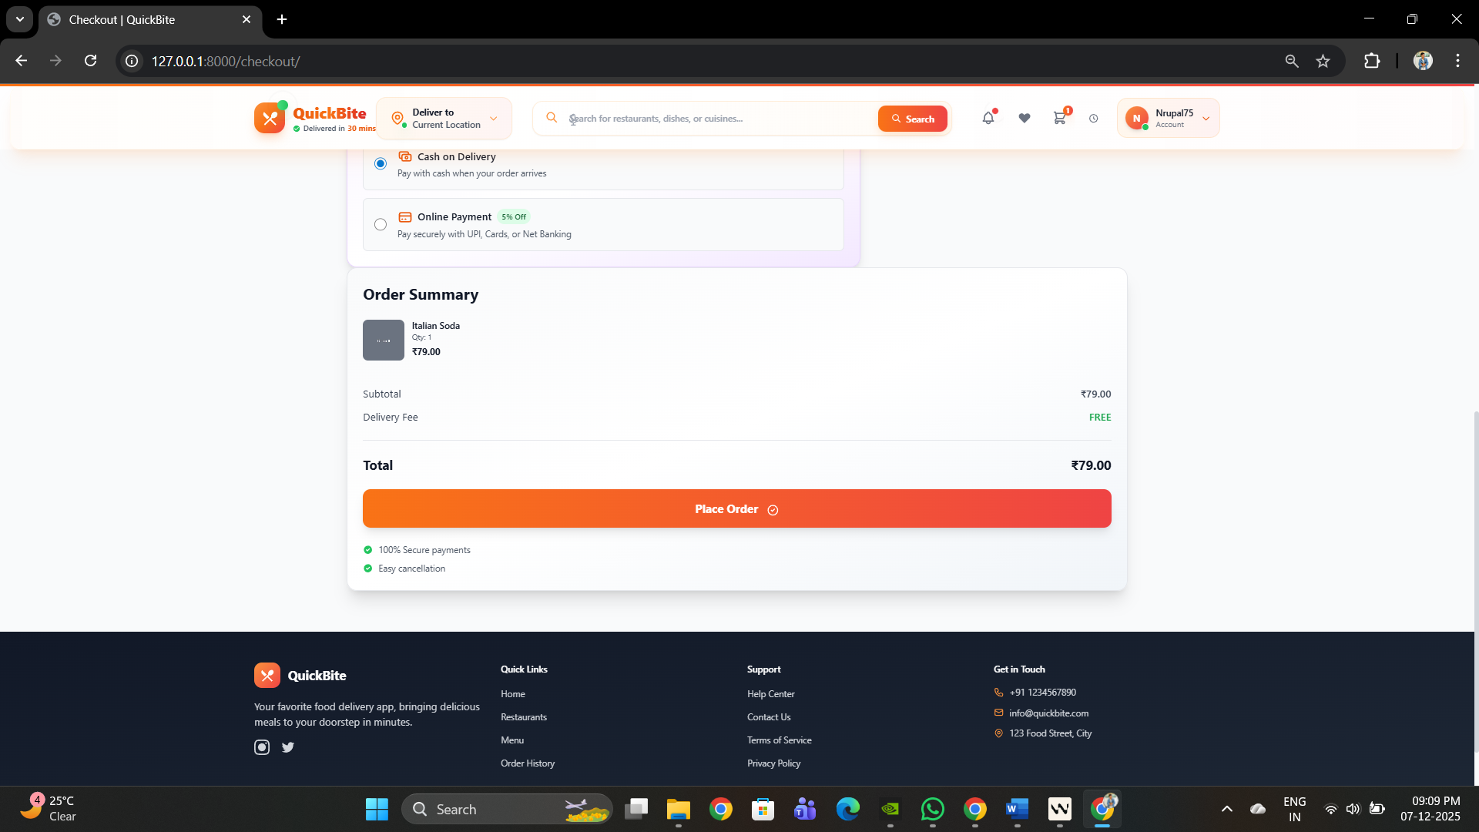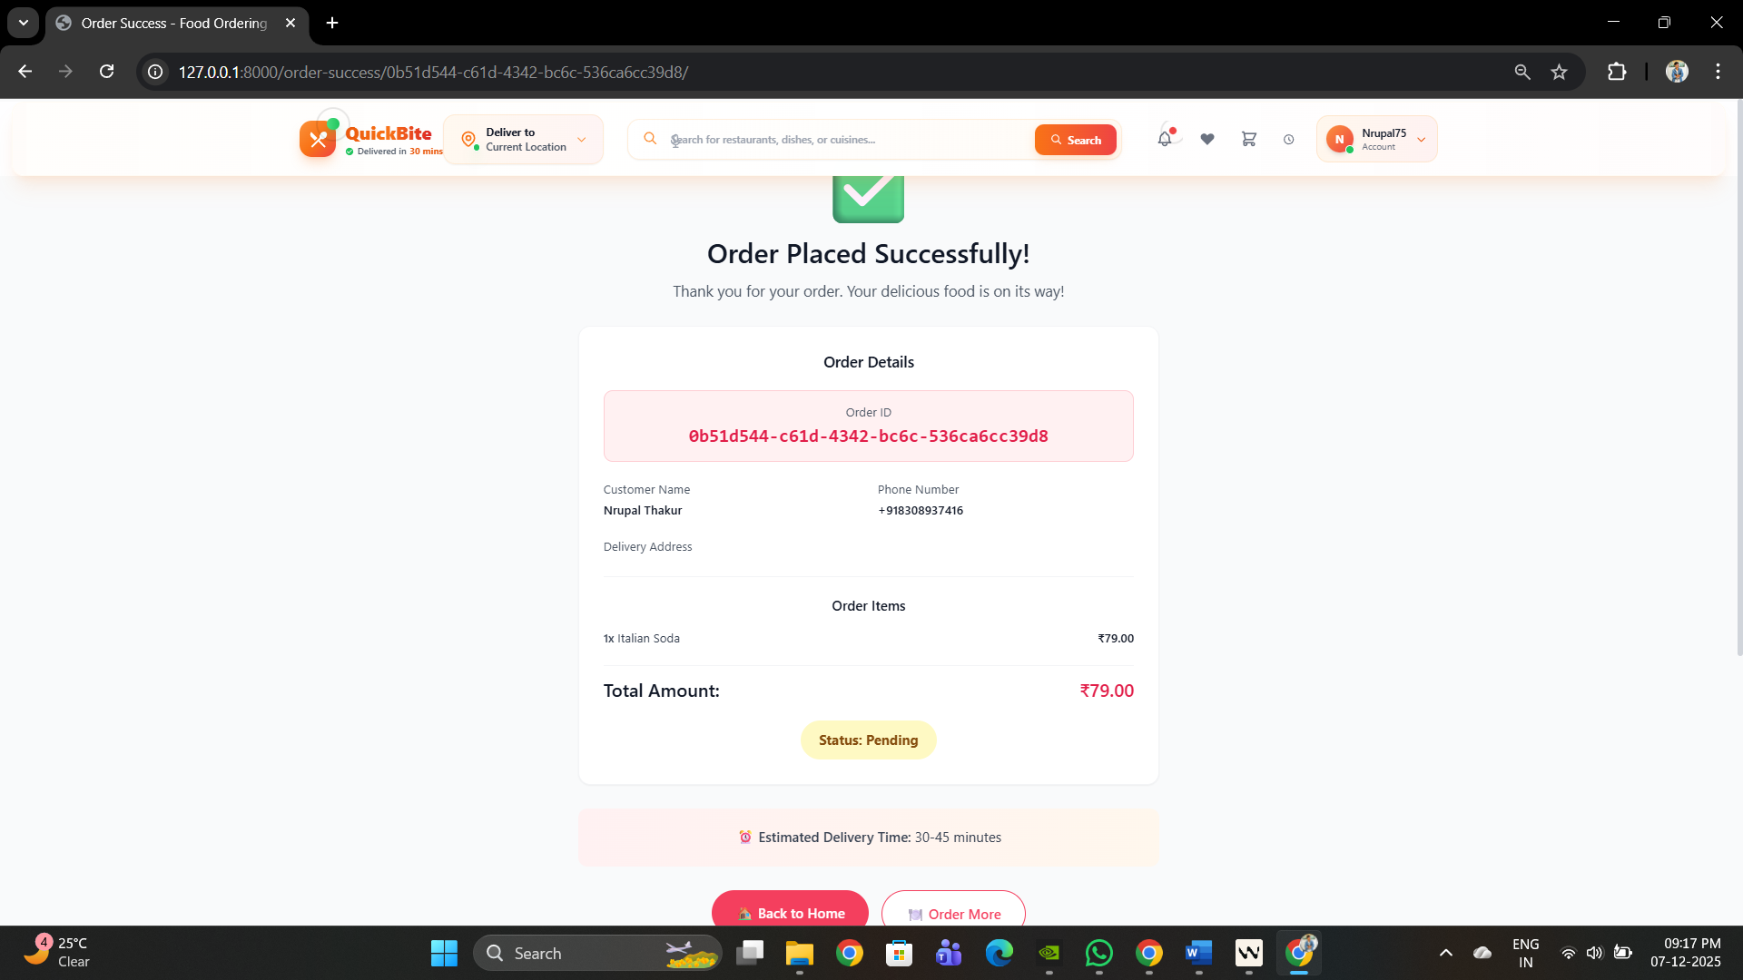

Restaurant

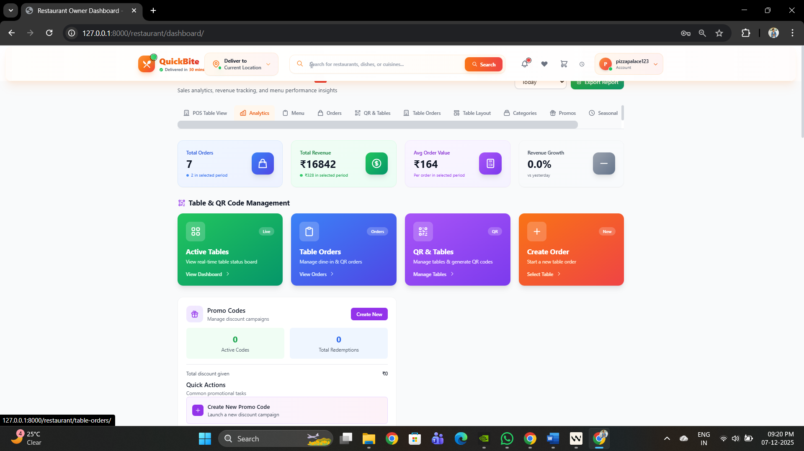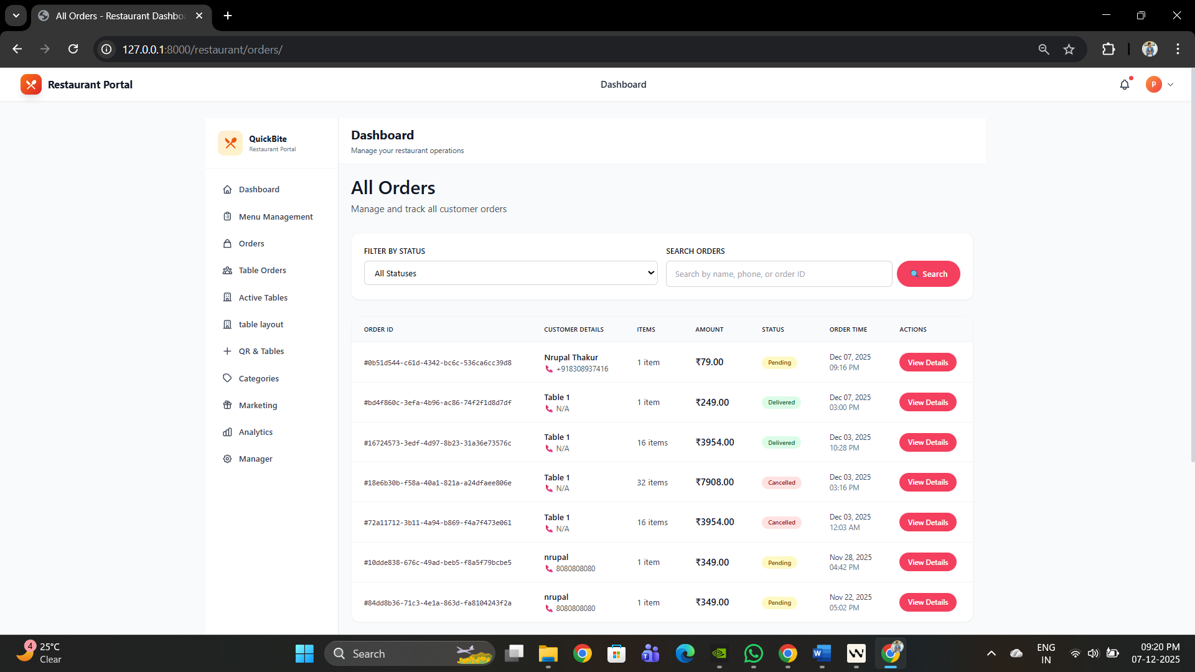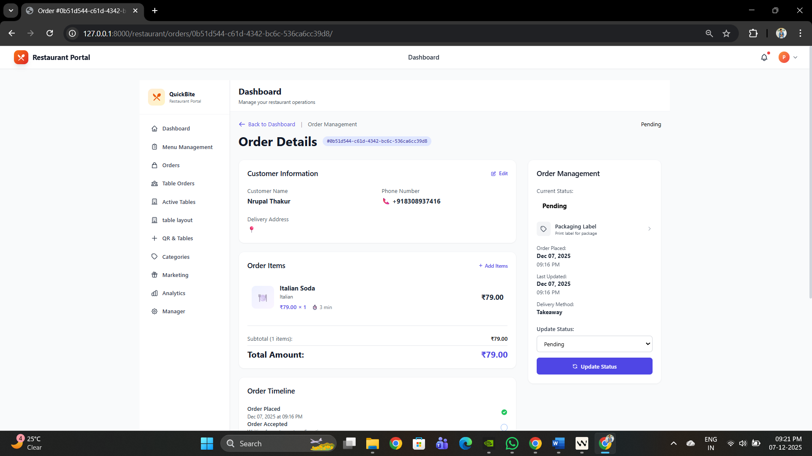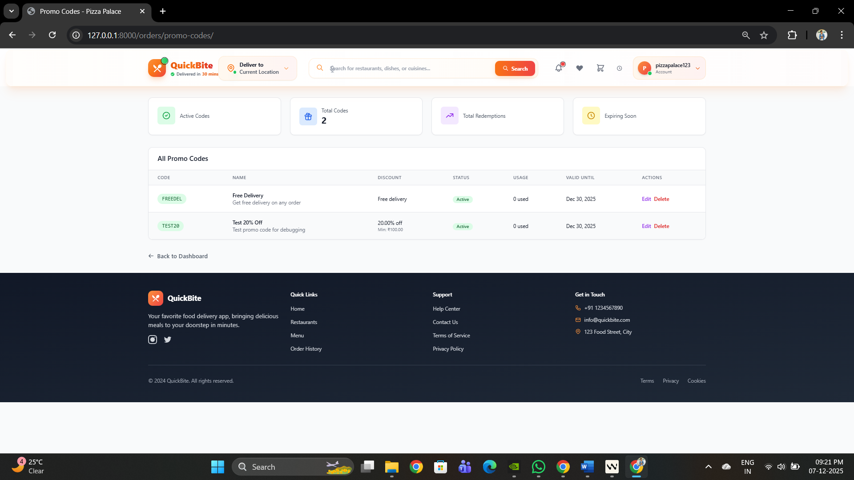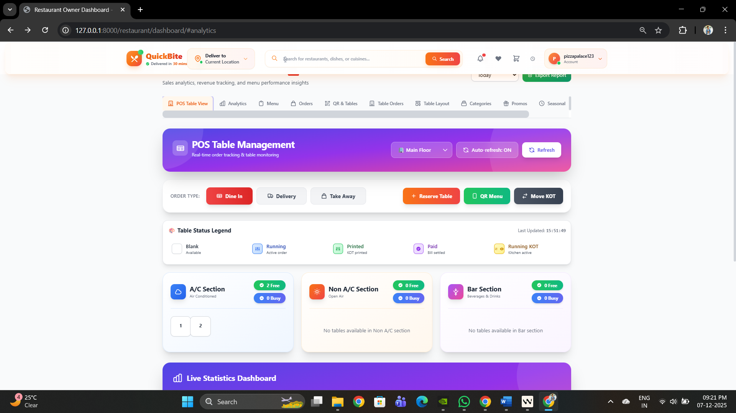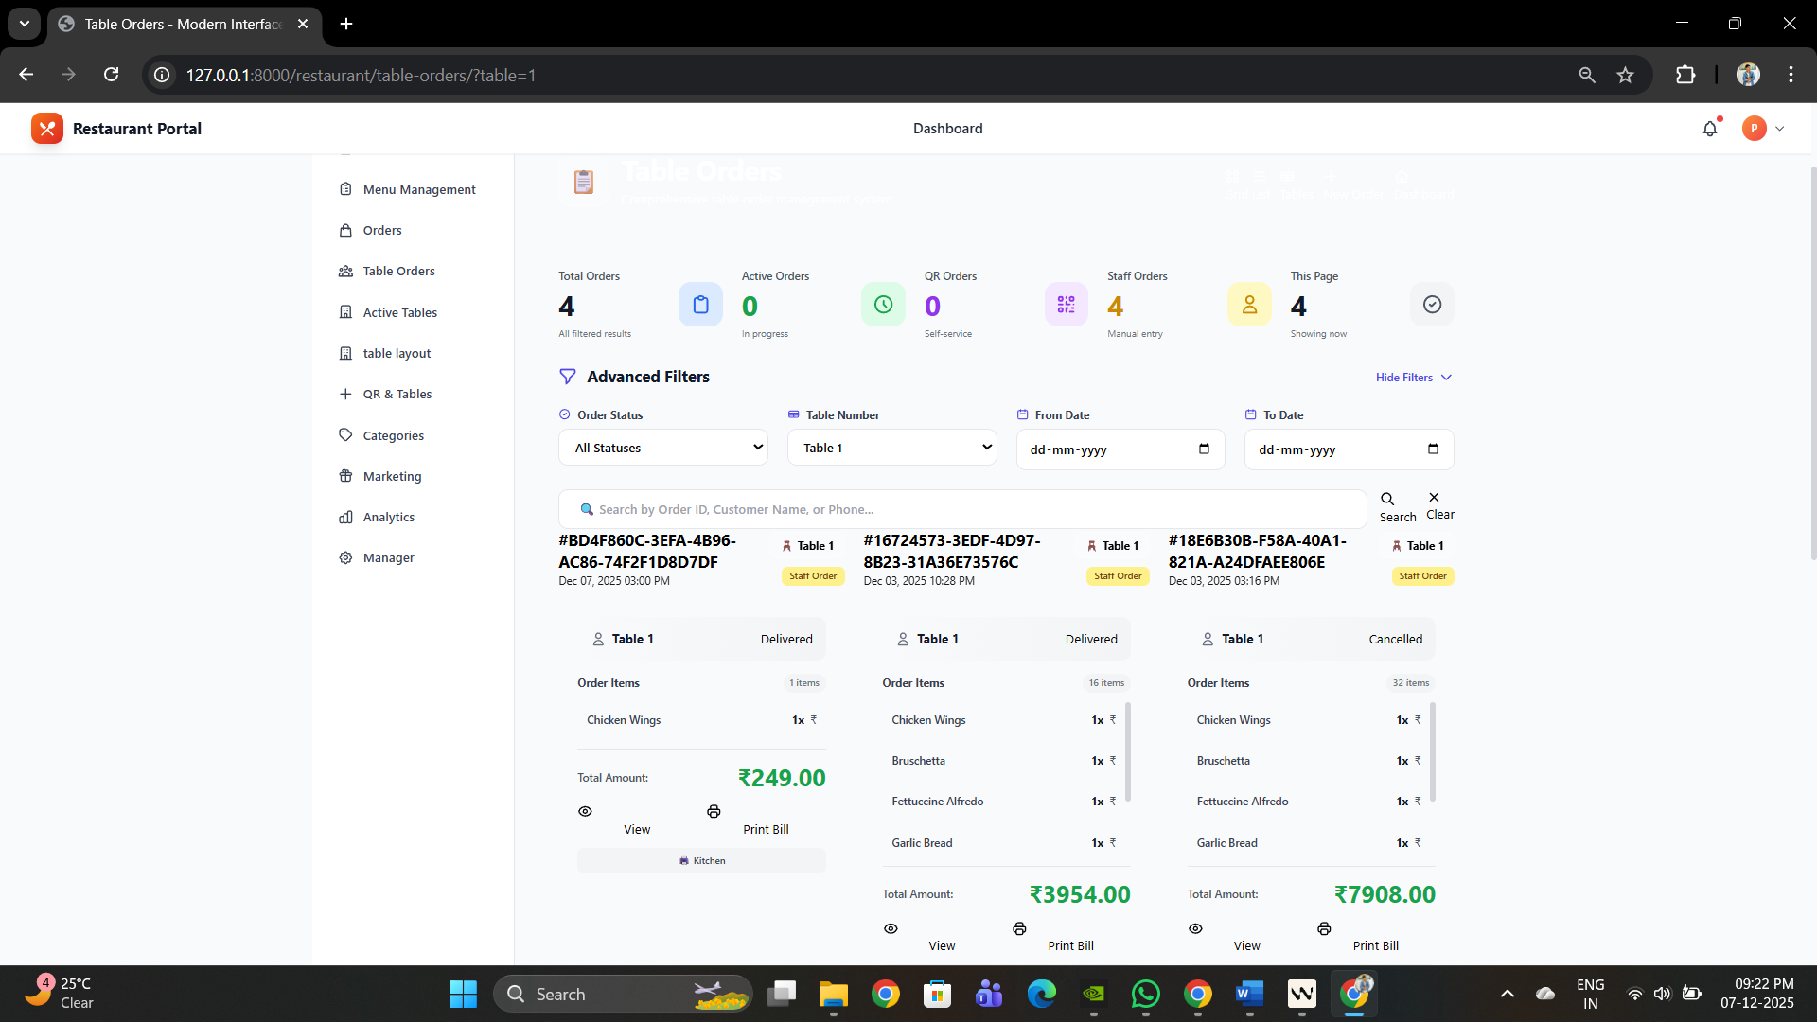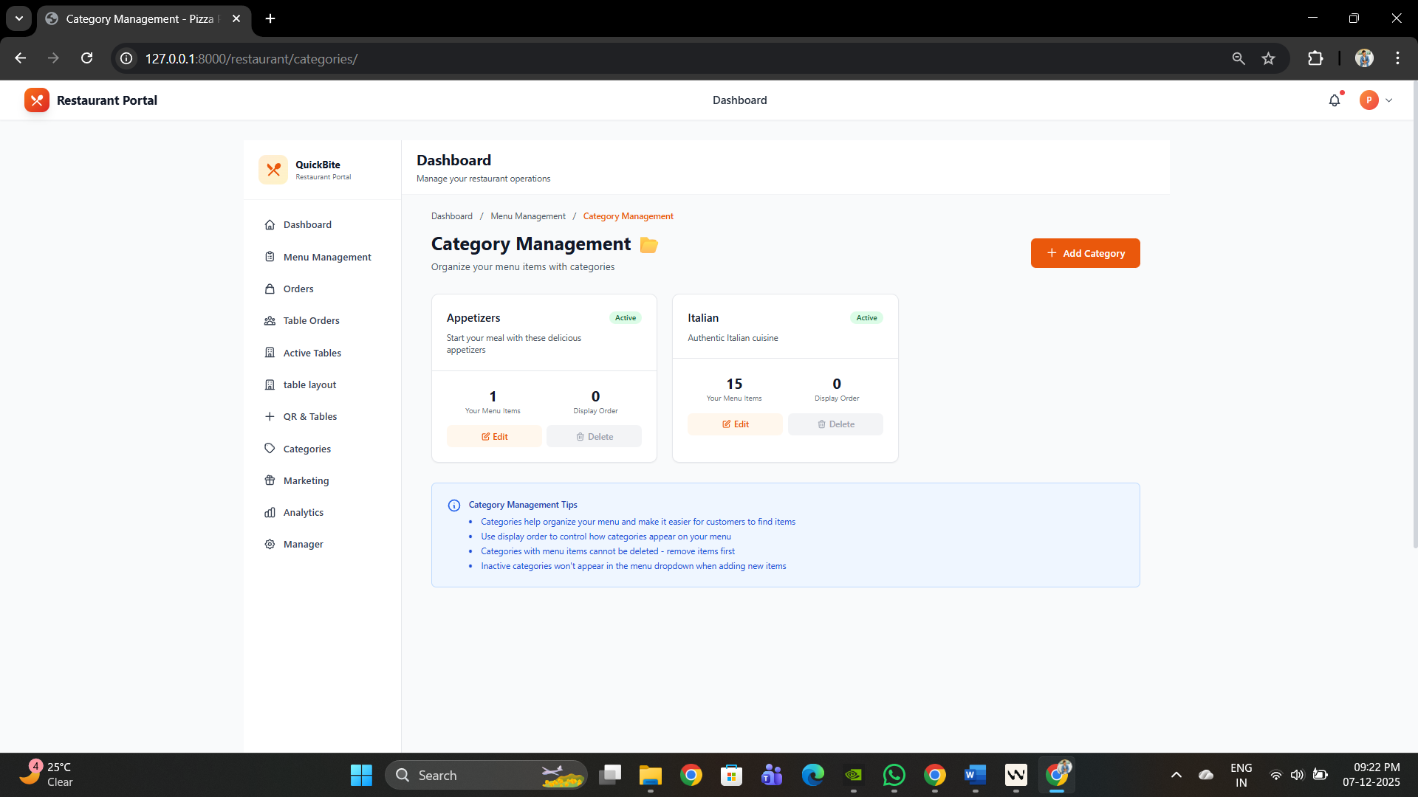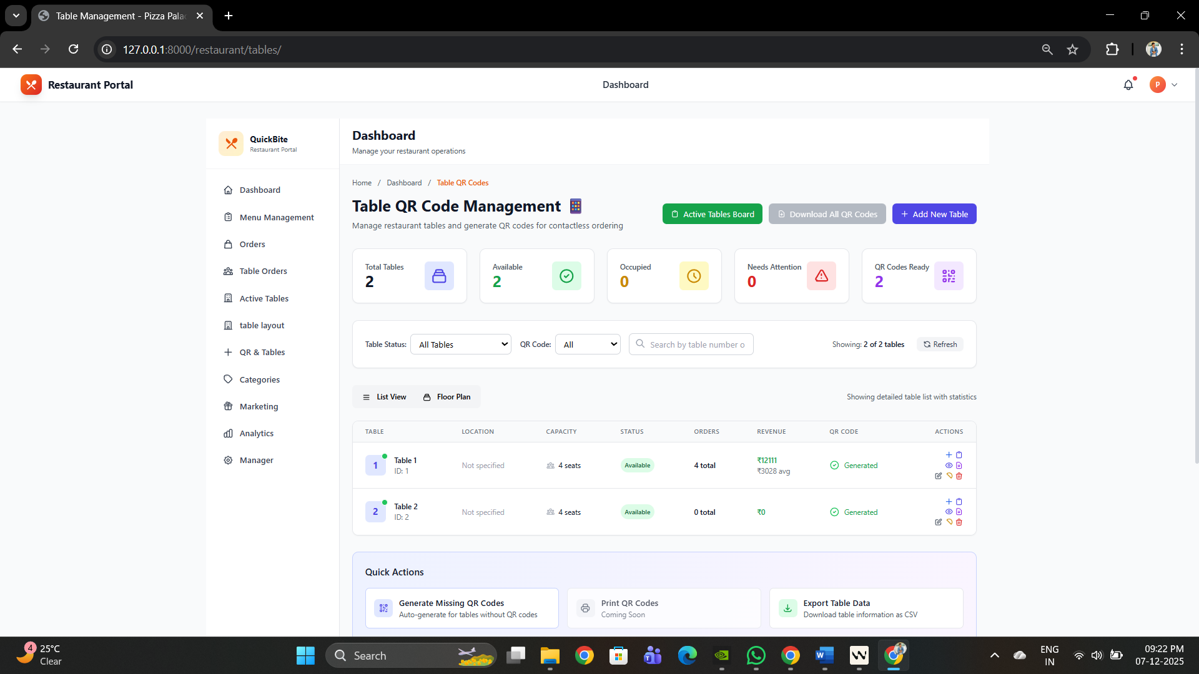

Admin 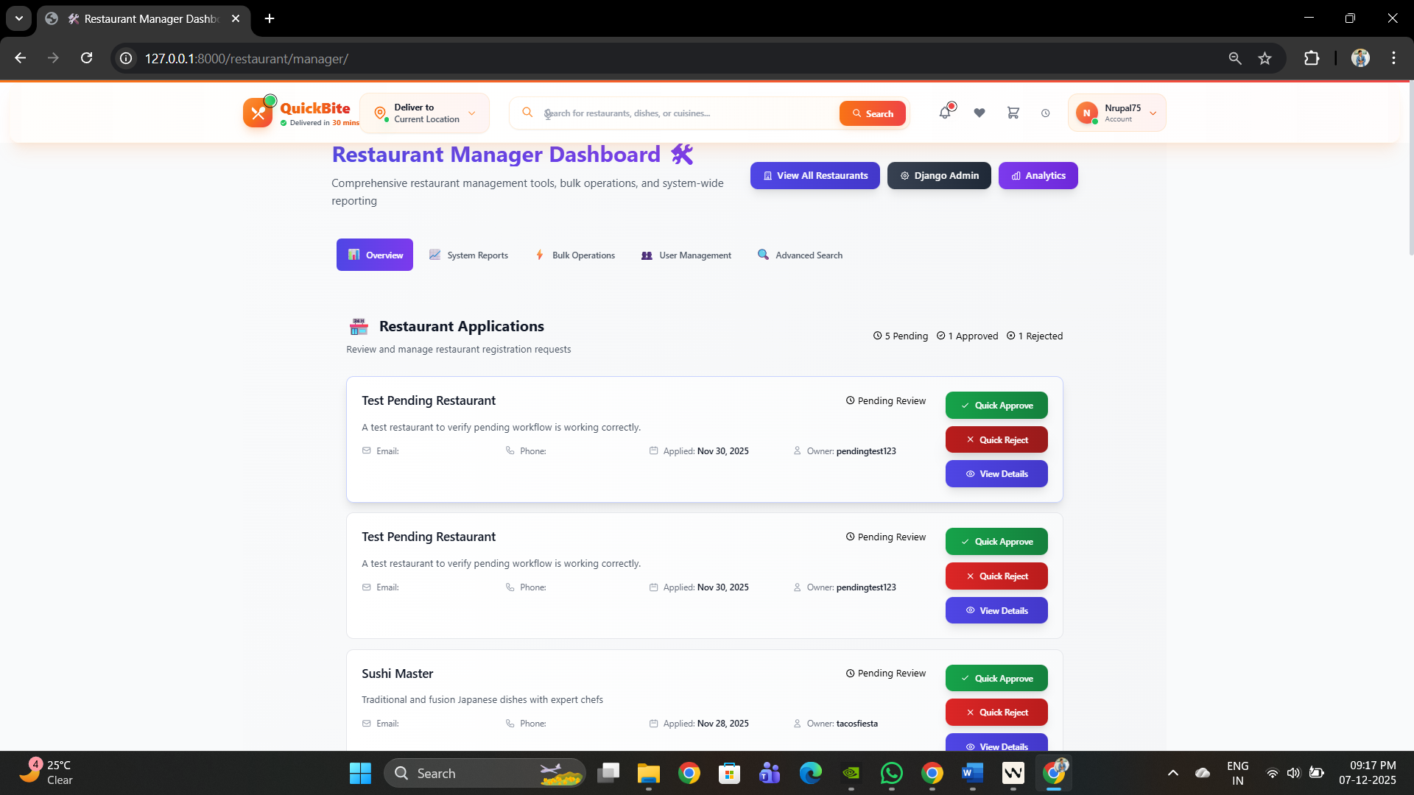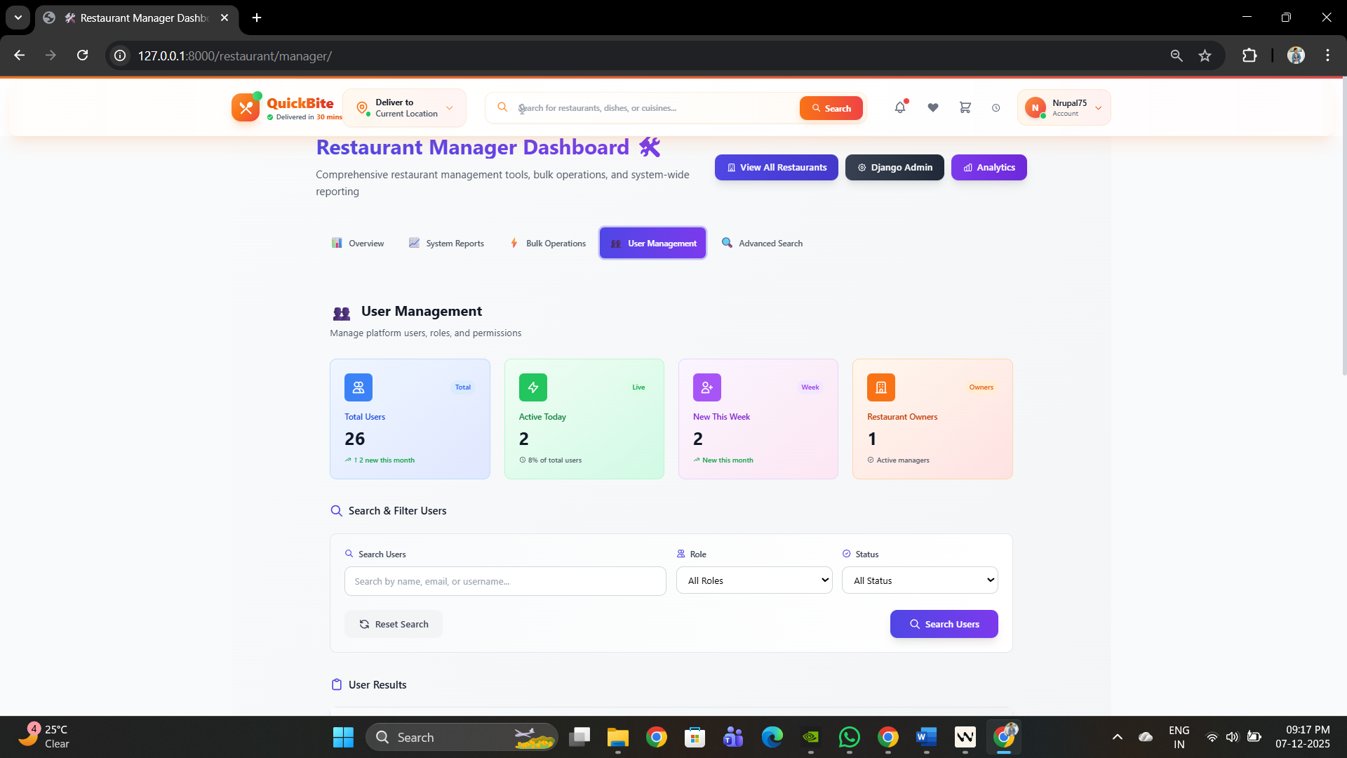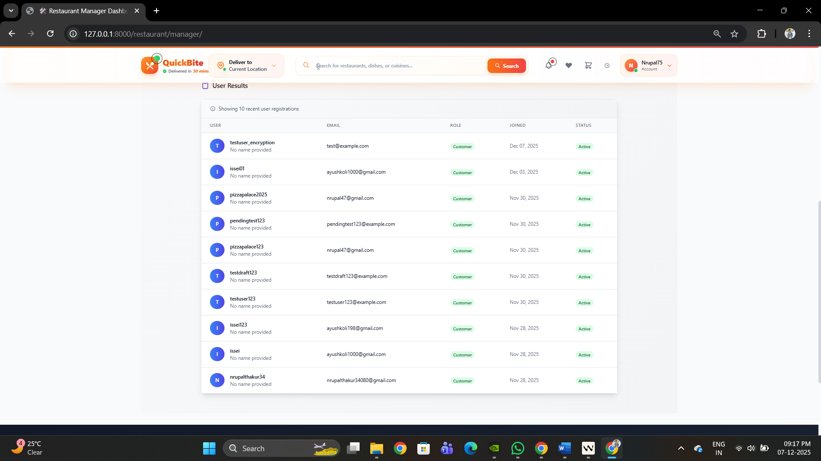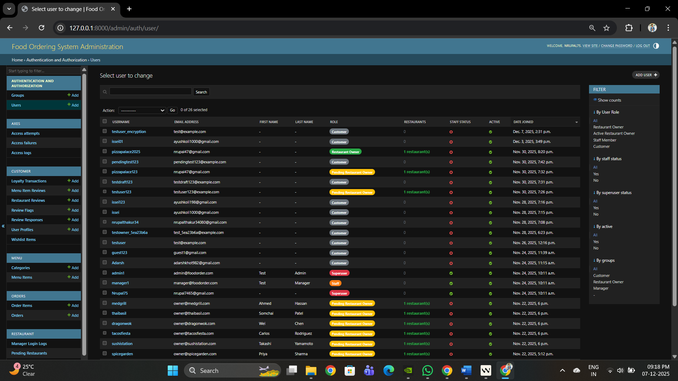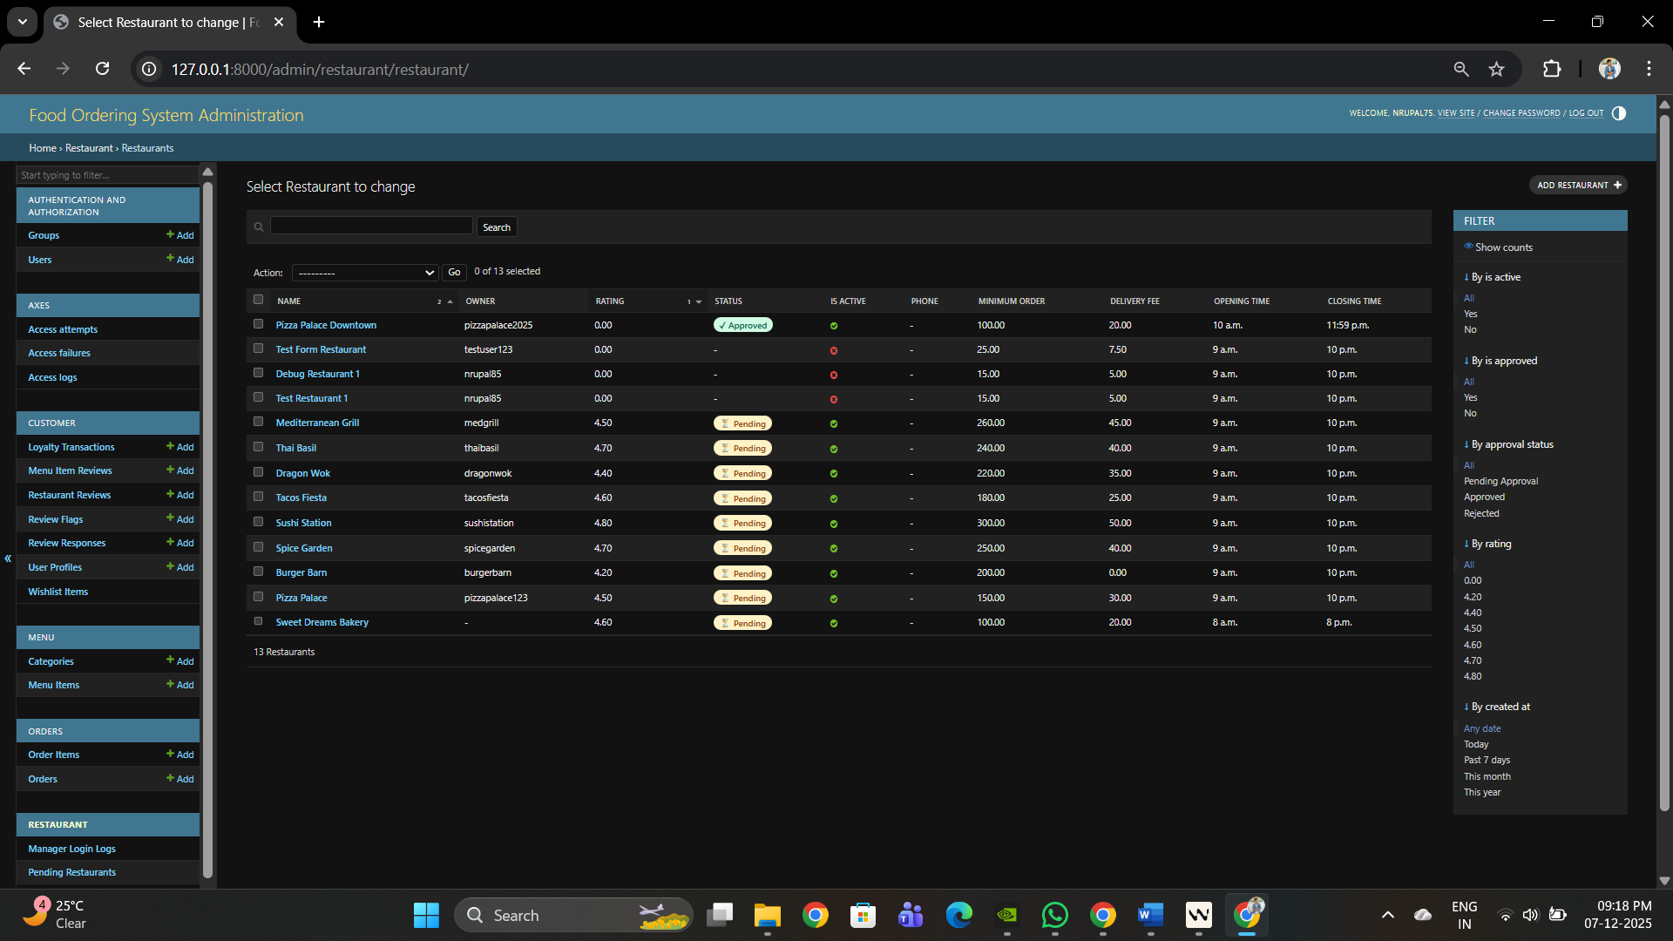

**CHAPTER 4 : TESTING AND IMPLEMENTATION**

**4.1. Testing Methodology**

Testing methodologies in Software Testing are nothing more than strategies designed to tackle one of the biggest problems in development; finding errors and fixing them. With every passing minute, the deck of technologies, coding languages, possible integrations, and more is growing in sheer number. We cannot expect to have only one set methodology for every other kind of development process.

**4.2 Unit Testing**

I have used Unit Testing Methodology. Unit testing is the process of testing different units or components of a tour management system to make sure they work properly in isolation. Here is how unit testing works:

1. Functional Testing : Verifying all features work according to specification.
2. Performance Testing: Assessing response times under various loads.
3. Security Testing: Identifying vulnerabilities in authentication and authorization.
4. Usability Testing: Evaluating user interface and experience

**4.3 Module Testing**

In software development, module testing, also called component testing, is the process of testing individual modules (units of code) within the software system. It’s the process of testing each component (unit of code) of a software system separately from the rest. The goal of module testing is to make sure that each module does what it is supposed to do and performs as expected. This usually includes testing the module’s input and output, boundary condition testing, and verifying the behavior of the module under various conditions. By testing each component separately, developers can identify and fix problems in individual components before they can be integrated into a larger system. This makes it easier to isolate and debug issues, resulting in a more reliable and robust software system.

**4.4 System Testing :**

Software systems are tested as a whole during the system testing step of the testing process. System testing entails putting the integrated system to the test to make sure it satisfies requirements and operates as intended in its intended setting. Instead of testing specific parts of the system, it evaluates the system's overall functionality, performance, dependability, and security.

**4.5 Alpha Testing:**

The organization's software development team handles alpha testing, usually in a controlled setting.

Its goal is to find any defects, usability problems, or other problems with the software before it is made available to outside users.

Developers, testers, and other stakeholders in the company can all serve as testers.

Testing the software's overall quality, performance, and functioning is the main goal.

**4.6 Beta Testing:**

A small group of outside users, often referred to as beta testers or beta users, conduct beta testing.

It is carried out outside of the organization's authority in a real-world setting. Before the program is made available to the public, the goal is to get input from actual users in order to find any problems or potential areas for development.

Feedback on the software's performance, usability, bugs, and other factors can be given by beta testers.

**4.7 White Box Black Box Testing**

**White-box testing**

White-box testing, sometimes referred to as structural or glass-box testing, entails dissecting the software's core logic and structure.

A comprehension of the code, including the paths, branches, and conditions, is the basis for test cases.

**Black box Testing :**

Functional testing, sometimes referred to as "black-box" testing, focuses on testing the software's exterior behavior without being aware of how it is implemented within.

The needs, features, and specifications of the software are the source of test cases.

The focus of testers is on inputs and outputs, boundary conditions, and expected behaviors; they do not have access to the source code.

**4.8 Implementation**

Implementing a tour management system involves several key steps to develop and deploy the software effectively. Here's an outline of the implementation process:

**Acquisition of Requirements:**

Document functional and non-functional requirements, including features, user roles, security requirements, and performance expectations.

**System Design:**

Design the architecture and data model of the tour management system based on the gathered requirements.

**Development:**

Develop the tour management system according to the specified requirements and design.

**Testing:**

Conduct unit testing to verify the functionality of individual components or modules.

Perform integration testing to ensure that different parts of the system work together seamlessly.

**Deployment:**

Prepare the tour management system for deployment to production or staging environments. Configure servers, databases, and other infrastructure components as needed.

**Maintenance and Support:**

Monitor the performance and stability of the tour management system in production.

Address any bugs, issues, or enhancement requests that arise post-deployment.

**Post Implementation**

- **Performance Monitoring :**  Real-time metrics tracking with application monitoring tools

- **Error Tracking** : Automated error reporting and alerting system

- **Backup Strategy** : Daily automated database and file backups

- **Security Updates** : Regular security patches and dependency updates

**User Support and Training**

- **Documentation** : Comprehensive user manuals and admin guides

- **Support System** : Ticket-based support for technical issues

- **Training Materials** : Video tutorials and walkthrough guides

- **FAQ Section :** Common questions and troubleshooting guides

## CHAPTER 5 : CONCLUSION AND REFERENCES

**5.1 Conclusion:**

The Food Ordering System successfully addresses the growing need for digital transformation in the restaurant industry by providing a comprehensive, scalable, and user-friendly platform for online food ordering and restaurant management. The system demonstrates the successful integration of modern web technologies to solve real-world business challenges.

Key achievements include:

-  **Complete Digital Solution**  End-to-end platform from restaurant discovery to order delivery

- **Robust Architecture** : Scalable Django-based system capable of handling growth

- **User-Centric Design** : Intuitive interfaces for both customers and restaurant staff

- **Business Intelligence** : Comprehensive analytics and reporting capabilities

- **Security and Reliability** : Enterprise-grade security measures and system stability

The system has proven its effectiveness through rigorous testing, successful beta deployment, and positive user feedback. It provides a solid foundation for restaurant digital transformation while maintaining flexibility for future enhancements and scalability.

**5.2 Limitation of System**

Despite its comprehensive features, the system has certain limitations that should be acknowledged:

**Technical Limitations**

1. **Scalability Challenges** : While designed for growth, the current architecture may require significant optimization for handling enterprise-scale traffic (1000+ concurrent restaurants)

2. **Real-time Features** : Current implementation lacks real-time notifications, requiring users to manually refresh for order updates

3. **Mobile Application** : No dedicated mobile app, limiting user experience on mobile devices

**Business Limitations**

1. **Geographic Constraints** : Currently designed for single-region deployment, requiring modifications for multi-country operations

2. **Payment Integration** : Limited payment gateway options, potentially restricting customer payment preferences

3.**Delivery Logistics :** No integrated delivery personnel management system

**Operational Limitations**

1. **Initial Setup Complexity** : Restaurant onboarding requires technical assistance for non-technical users

2. **Customization Limitations :** Limited options for restaurant-specific branding and workflow customization

3. **Dependency on Internet** : Complete system dependency on internet connectivity may affect operations during outages

**5.3 Future Scope for Modification:**

The system has significant potential for future enhancements and expansions:

**Phase 2 Enhancements (6-12 months)**

1. **Mobile Applications** : Native iOS and Android apps for enhanced mobile experience

2. **Real-time Notifications** : WebSocket implementation for live order updates

3. **Advanced Analytics** : Machine learning-powered insights and predictive analytics

4. **Multi-payment Integration** : Additional payment gateways and digital wallet support

5. **Delivery Personnel Module** : Complete delivery management system with route optimization

**#### Phase 3 Enhancements (12-24 months)**

1. **Multi-restaurant Marketplace** : Expansion to support multiple cities and regions

2. **AI-Powered Recommendations** : Personalized restaurant and food recommendations

3. **Voice Ordering** : Integration with voice assistants for hands-free ordering

4. **Blockchain Integration** : Supply chain transparency and loyalty program management

5. **IoT Integration** : Smart kitchen equipment integration for automated order processing

**Long-term Vision (24+ months)**

1. **nternational Expansion** : Multi-currency, multi-language support

2. **B2B Solutions** : Catering and bulk ordering for corporate clients

3. **Franchise Model :** White-label solution for restaurant chains

4. **Sustainability Features** : Carbon footprint tracking and eco-friendly ordering options

**5.4.1. H/W Requirement**

Front-end : HTML, CSS, Javascript

Back-end : PHP

Database : MySql

**5.4.2. S/W Requirement**

Front-end : HTML, CSS, Javascript

Back-end : Python

Database : MySql

**5.5. References/ Bibliography**

* https://docs.spring.io/spring-framework/reference/
* https://docs.spring.io/springboot/docs/current/reference/html/
* https://hibernate.org/orm/documentaƟon/
* https://getbootstrap.com/docs/
* https://dev.mysql.com/doc/

## CHAPTER 6 : ANNEXURES

• **Menu Flow Diagram**

+-------------------+     +-------------------+

|   Customer Login  |     |  Restaurant Login |

+-------------------+     +-------------------+

|                         |

v                         v

+-------------------+     +-------------------+

|  Browse Restaurants|    | Restaurant Dashboard|

+-------------------+     +-------------------+

|                         |

v                         v

+-------------------+     +-------------------+

|  View Menu Items  |     |  Manage Orders    |

+-------------------+     +-------------------+

|                         |

v                         v

+-------------------+     +-------------------+

|  Add to Cart      |     |  Update Menu      |

+-------------------+     +-------------------+

|                         |

v                         v

+-------------------+     +-------------------+

|  Checkout Process |     |  View Analytics   |

+-------------------+     +-------------------+

|                         |

v                         v

+-------------------+     +-------------------+

|  Payment & Order  |     |  Process Orders   |

+-------------------+     +-------------------+

|                         |

v                         v

+-------------------+     +-------------------+

|  Order Tracking   |     |  Update Status    |

+-------------------+     +-------------------+

**Data Dictionary**

Database: food_ordering_system

-- Table structure for table tbluser

CREATE TABLE tbluser (

id INT AUTO_INCREMENT PRIMARY KEY,

username VARCHAR(150) UNIQUE NOT NULL,

email VARCHAR(254) UNIQUE NOT NULL,

first_name VARCHAR(150),

last_name VARCHAR(150),

password VARCHAR(128) NOT NULL,

is_staff BOOLEAN DEFAULT FALSE,

is_active BOOLEAN DEFAULT TRUE,

date_joined DATETIME NOT NULL,

last_login DATETIME

);

-- Table structure for table tblrestaurant

CREATE TABLE tblrestaurant (

id INT AUTO_INCREMENT PRIMARY KEY,

name VARCHAR(200) NOT NULL,

owner_id INT NOT NULL,

description TEXT,

address TEXT NOT NULL,

phone VARCHAR(15) NOT NULL,

email VARCHAR(254),

cuisine_type VARCHAR(50) NOT NULL,

rating DECIMAL(3,2) DEFAULT 0.00,

minimum_order DECIMAL(10,2) DEFAULT 0.00,

delivery_fee DECIMAL(10,2) DEFAULT 0.00,

opening_time TIME,

closing_time TIME,

image VARCHAR(100),

is_active BOOLEAN DEFAULT TRUE,

is_approved BOOLEAN DEFAULT FALSE,

created_at DATETIME NOT NULL,

updated_at DATETIME NOT NULL,

FOREIGN KEY (owner_id) REFERENCES tbluser(id)

);

-- Table structure for table tblcategory

CREATE TABLE tblcategory (

id INT AUTO_INCREMENT PRIMARY KEY,

name VARCHAR(100) UNIQUE NOT NULL,

description TEXT,

is_active BOOLEAN DEFAULT TRUE,

display_order INT DEFAULT 0,

created_at DATETIME NOT NULL,

updated_at DATETIME NOT NULL

);

-- Table structure for table tblmenuitem

CREATE TABLE tblmenuitem (

id INT AUTO_INCREMENT PRIMARY KEY,

restaurant_id INT NOT NULL,

category_id INT NOT NULL,

name VARCHAR(200) NOT NULL,

description TEXT NOT NULL,

price DECIMAL(10,2) NOT NULL,

image VARCHAR(100),

is_available BOOLEAN DEFAULT TRUE,

dietary_type VARCHAR(10) DEFAULT 'veg',

preparation_time INT DEFAULT 15,

created_at DATETIME NOT NULL,

updated_at DATETIME NOT NULL,

FOREIGN KEY (restaurant_id) REFERENCES tblrestaurant(id),

FOREIGN KEY (category_id) REFERENCES tblcategory(id)

);

-- Table structure for table tblorder

CREATE TABLE tblorder (

id INT AUTO_INCREMENT PRIMARY KEY,

order_id CHAR(36) UNIQUE NOT NULL,

user_id INT,

customer_name VARCHAR(200) NOT NULL,

customer_phone VARCHAR(15) NOT NULL,

customer_address TEXT,

delivery_method VARCHAR(20) DEFAULT 'delivery',

total_amount DECIMAL(10,2) NOT NULL,

status VARCHAR(20) DEFAULT 'pending',

notes TEXT,

created_at DATETIME NOT NULL,

updated_at DATETIME NOT NULL,

FOREIGN KEY (user_id) REFERENCES tbluser(id)

);

-- Table structure for table tblorderitem

CREATE TABLE tblorderitem (

id INT AUTO_INCREMENT PRIMARY KEY,

order_id INT NOT NULL,

menu_item_id INT NOT NULL,

quantity INT NOT NULL DEFAULT 1,

price DECIMAL(10,2) NOT NULL,

subtotal DECIMAL(10,2) NOT NULL,

special_instructions TEXT,

created_at DATETIME NOT NULL,

updated_at DATETIME NOT NULL,

FOREIGN KEY (order_id) REFERENCES tblorder(id),

FOREIGN KEY (menu_item_id) REFERENCES tblmenuitem(id)

);

-- Table structure for table tblproduct

CREATE TABLE tblproduct (

Pid VARCHAR(45) PRIMARY KEY,

Pname VARCHAR(100),

Ptype VARCHAR(20),

Pinfo VARCHAR(350),

Pprice VARCHAR(12,2),

Pquantity INT,

Pimage LONGBLOB

);

* **Sample Input**
* **Sample Output :**